34.Design DFA using simulator to accept even number of c’s over the set {a,b,c}

INPUT:

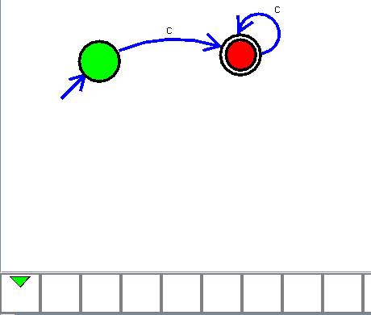

OUTPUT:  
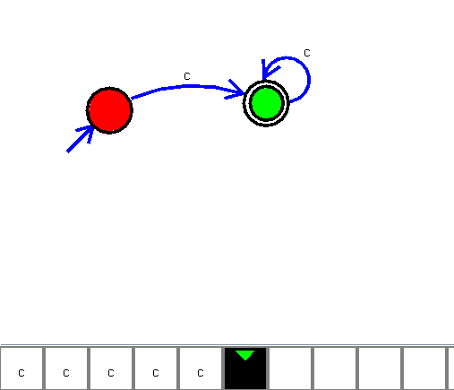

RESULTS:

The implementation of DFA using simulator to accept even number of c’s over the set {a,b,c}